# COMP3500: Project 2 Modify the Kernel

**Xiao Qin @ Auburn University**

**Note:** I rebuilt the kernel by adding "hello world!" into the boot message. In what follows, I summarize my process of rebuilding the OS161 kernel. You may also found the three common mistakes at the end of this document.

Your hello.c should be as simple as the following code:

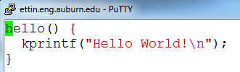

When we compile OS161 after adding hello.c, we may encounter the following compilation error.



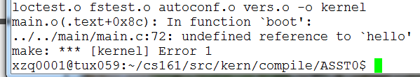

1. edit kern/conf/conf.kern

cd ~/cs161/src/kern/conf

vi conf.kern

/main.c #search main.c in conf.kern see also line 374

Add the following line:

file main/hello.c

2. In directory ~/cs161/src/kern/include

Create a header file called hello.h

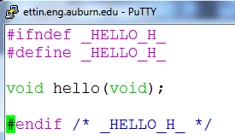

3. Add #include <hello.h> into main.c

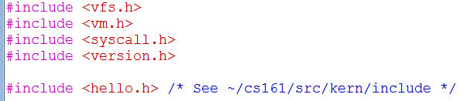

4. Important! Configure your tree for the machine on which you are working.

cd ~/cs161/src

./configure

5. Configure a kernel named ASST0.

cd ~/cs161/src/kern/conf

./config ASST0

6. Build the ASST0 kernel. (cs161/src/compile). Use ‘echo $PATH’ to check your $PATH.

cd ../compile/ASST0

make depend

make

**make install** Important!

7. Now also build the user level utilties.

cd ~/cs161/src

make

8. Run OS161: Change into your root directory.

%cd ~/cs161/root

Run the machine simulator on your operating system.

%./sys161 kernel

Now you should see the following outcome:

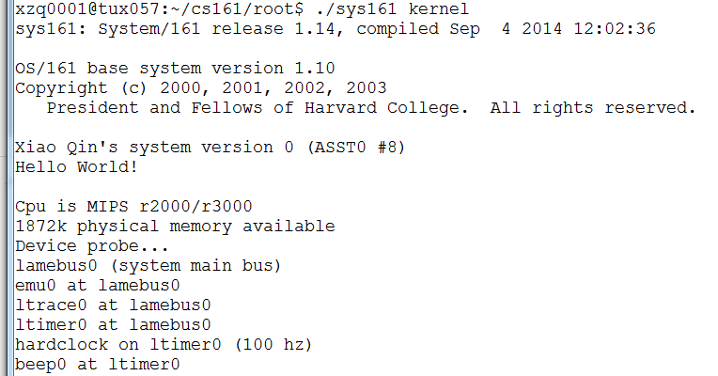

**Common Mistakes**

1. You must rebuild your kernel by following the three steps. If you forget to install the kernel using "make install", your kprintf() will not print “hello world”.

cd ../compile/ASST0

make depend

make

make install

2. In your hello.c, you must use kprintf() rather than printf().

3. Remember to setup PATH using the following command.

export PATH=~/cs161/bin:$PATH

If you forget to configure PATH, you will encounter the error message below.

